# Lab: Inheritance

Problems for exercises and homework for the ["C# OOP" course @ SoftUni"](https://softuni.bg/trainings/2244/csharp-oop-february-2019).

You can check your solutions here: <https://judge.softuni.bg/Contests/1499/Inheritance-Lab>

# Part I: Inheritance

## Single Inheritance

**NOTE**: You need a public StartUp class with the namespace **Farm**.

Create two classes named Animal and Dog.

Animal with a single public method Eat() that prints: **"eating…"**

Dog with a single public method Bark() that prints: **"barking…"**

Dog should inherit from Animal.

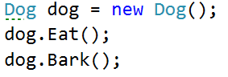

### Hints

Use the **: operator** to build a hierarchy

## Multiple Inheritance

**NOTE**: You need a public StartUp class with the namespace **Farm**.

Create three classes named Animal, Dog and Puppy.

Animal with a single public method Eat() that prints: **"eating…"**

Dog with a single public method Bark() that prints: **"barking…"**

Puppy with a single public method Weep() that prints: **"****weeping…"**

Dog should inherit from Animal. Puppy should inherit from Dog.

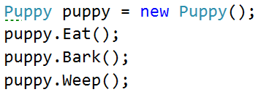

## Hierarchical Inheritance

**NOTE**: You need a public StartUp class with the namespace **Farm**.

Create three classes named Animal, Dog and Cat.

Animal with a single public method Eat() that prints: **"eating…"**

Dog with a single public method Bark() that prints: **"barking…"**

Cat with a single public method Meow() that prints: **"meowing…"**

Dog and Cat should inherit from Animal.

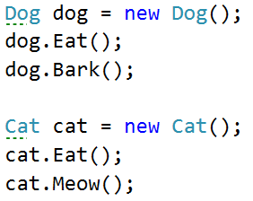

# Part II: Reusing Classes

## Random List

**NOTE**: You need a public StartUp class with the namespace **CustomRandomList**.

Create a RandomList class that has all the functionality of List<string>.

Add additional function that **returns** and **removes** a random element from the list.

* Public method: RandomString(): string

## Stack of Strings

**NOTE**: You need a public StartUp class with the namespace **CustomStack**.

Create a class StackOfStrings which extends **Stack** and can store only strings and has the following functionality:

* Public method: IsEmpty(): bool
* Public method: **AddRange(): Stack<string>**